- Though President Trump temporarily suspended his administration's reciprocal tariffs on most countries this week, higher tariffs on China leave the overall effective tariff rate little changed from last week. And with trade policy uncertainty set to remain very high, we still plan to cut our near-term UK growth projections as part of our global forecast update on April 15.
- The Office for National Statistics reported that GDP rose by 0.5% month-on-month in February. But this is hard to square with other data and we see it as further evidence that the ONS has a major problem with residual seasonality.
It's been another week of US tariff announcements and turbulence in global financial markets. In what was likely a response to signs of rising stress in the US Treasury market, US President Donald Trump announced a 90-day suspension of the higher reciprocal tariffs he imposed on 57 countries on April 2. During the suspension, the 10% minimum tariff rate will apply to US imports from these countries, while higher tariffs on specific goods, such as cars, steel, and aluminium, will remain in effect. The one exception is China, with the US President raising the tariff rate on most Chinese imports to 145% (Chart 1).
Last week, we outlined our plans to cut our UK growth forecasts as part of our global forecast update on April 15. This was on the basis that the US tariffs would directly weigh on UK exports, while the economy was also likely to suffer from the indirect effects of softer global demand and heightened trade policy uncertainty.
The net effect of scaling back the large reciprocal tariffs but increasing tariffs on China will be to leave the overall effective tariff rate little changed. And at this stage, it's hard to gauge what will happen to the reciprocal tariffs once the 90-day suspension has expired, so trade policy uncertainty is likely to remain very high. Therefore, we judge that the overall impact of US trade policy is likely to be similar to our original assessment and we still expect to cut our UK growth forecast significantly.
Chart 1: President Trump announced a pause on reciprocal tariffs for most countries except China
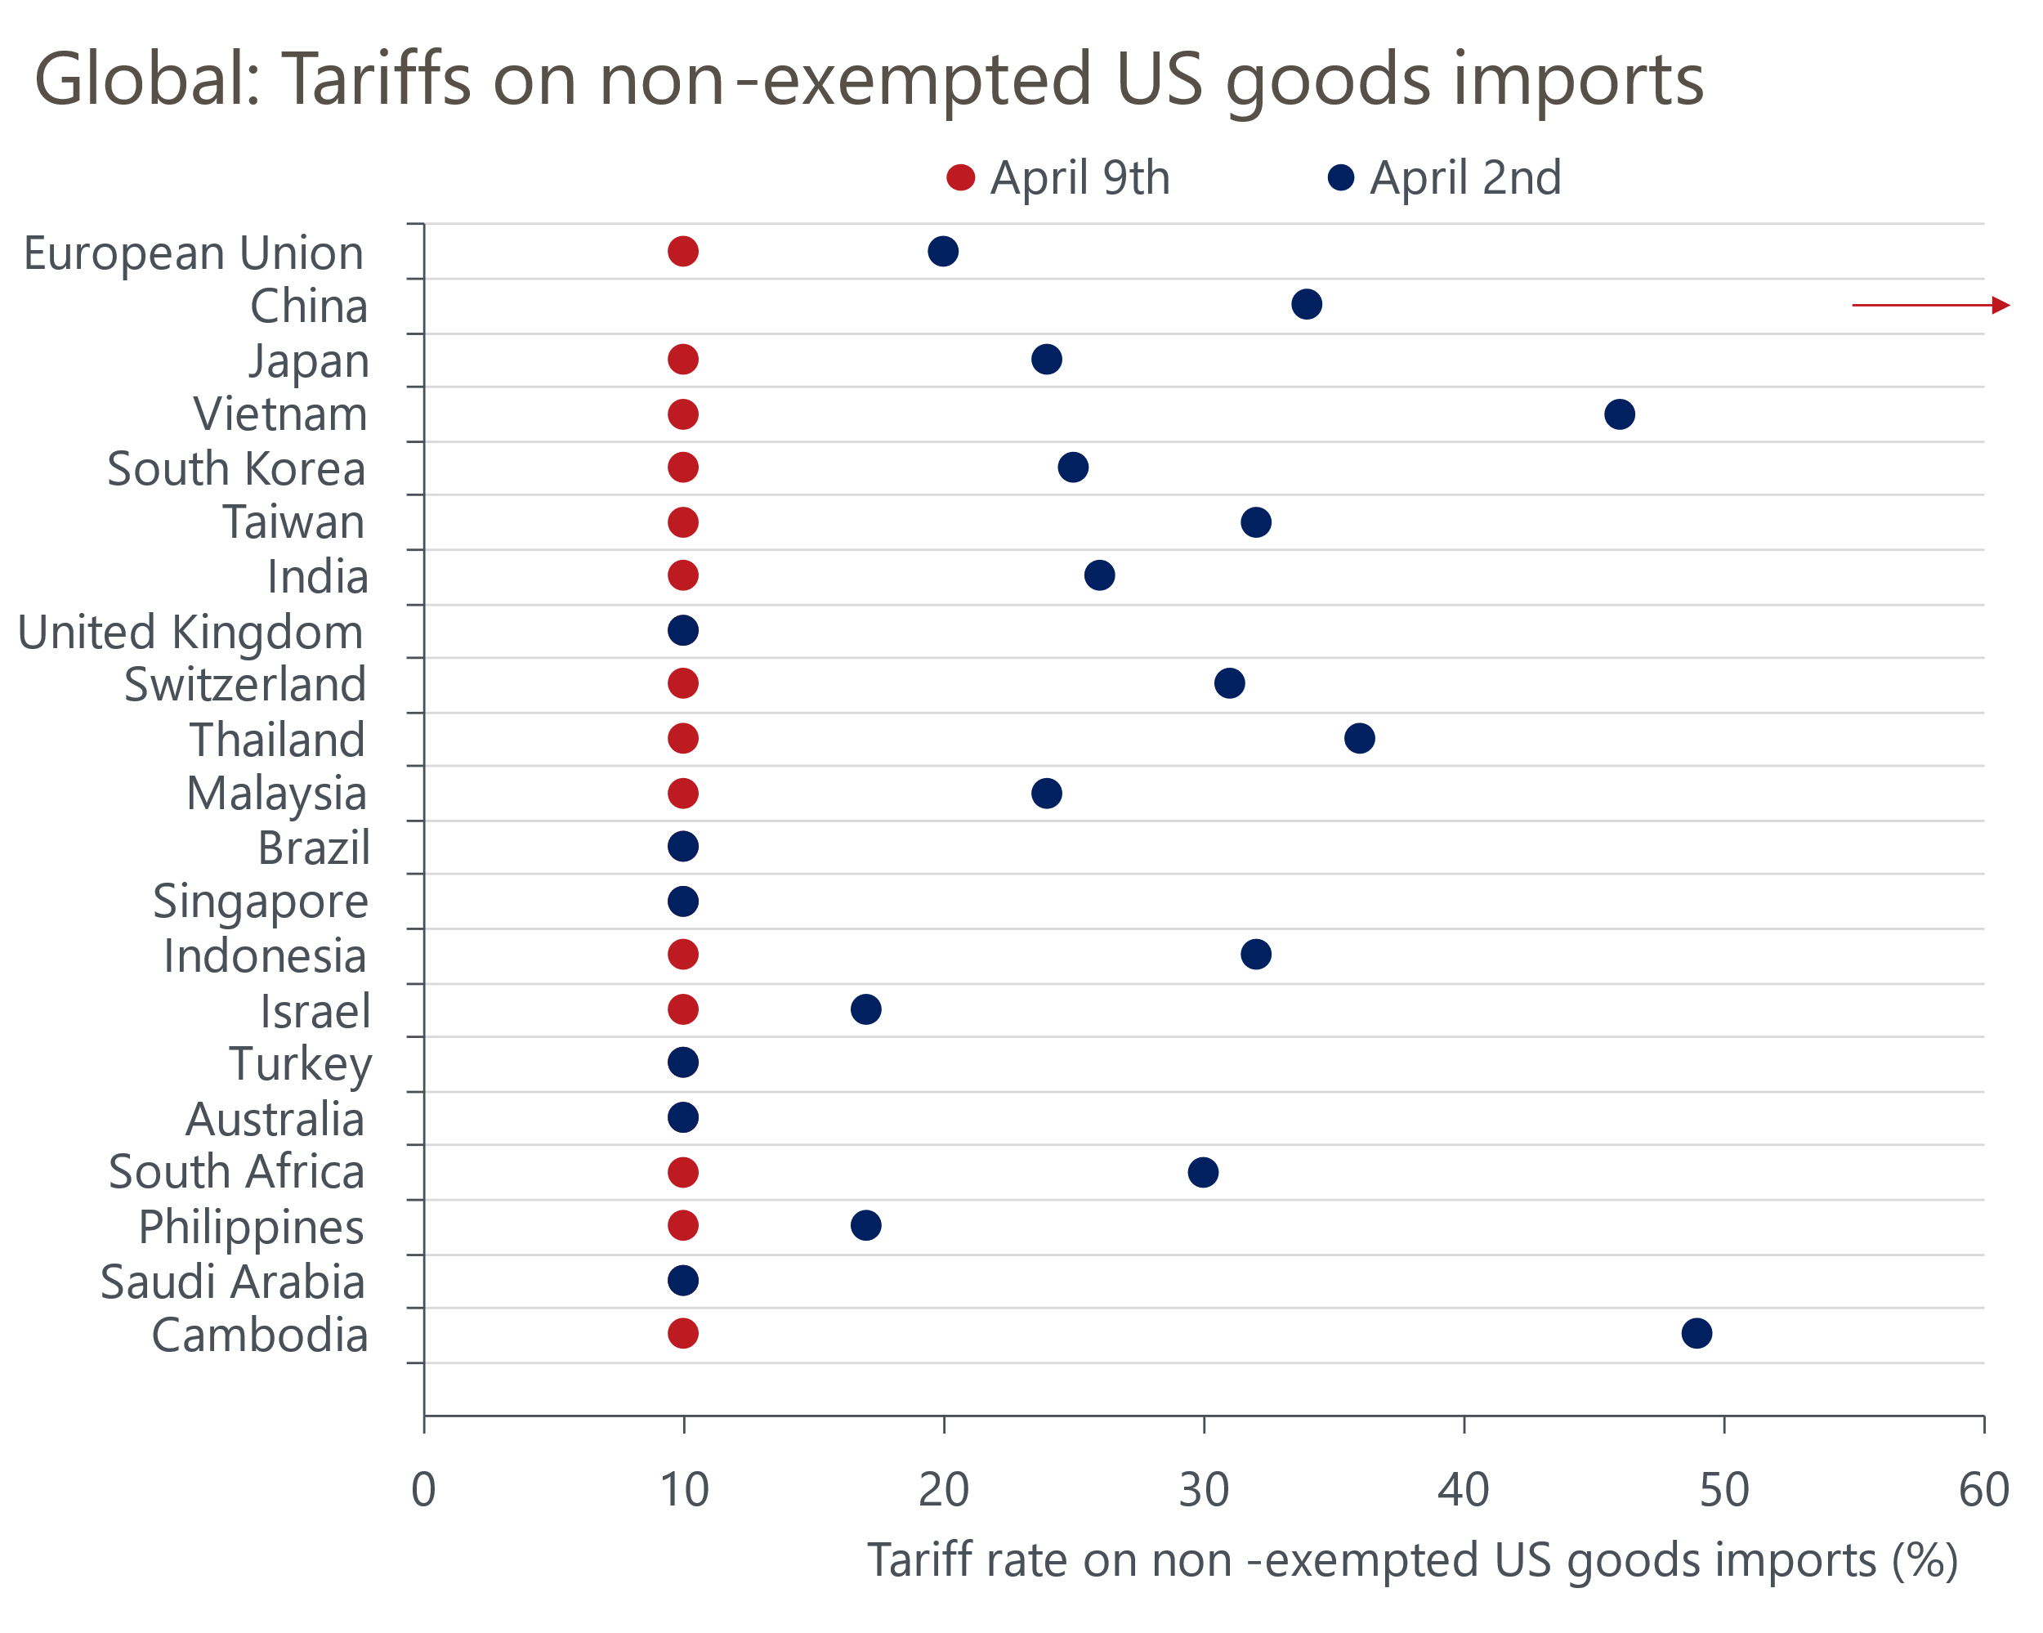
Source: White House

Where our GDP forecast ultimately lands will also be affected by this morning's output data for February. Following a flat reading in January, GDP picked up sharply in February, growing 0.5% month-on-month. But we think this upbeat outturn significantly overstates the underlying strength of the economy. The biggest gains at the sectoral level in February came from those that experienced large declines in January. Furthermore, we've regularly argued that the GDP data shows signs of suffering from residual seasonality, with strong starts to the year being followed by much weaker data in the second half. The February data provides further evidence of this problem, with the monthly pattern of the data published so far in 2025 closely tracking last year's outturns (Chart 2).
Chart 2: So far in 2025, the monthly pattern of GDP growth is very similar to last year
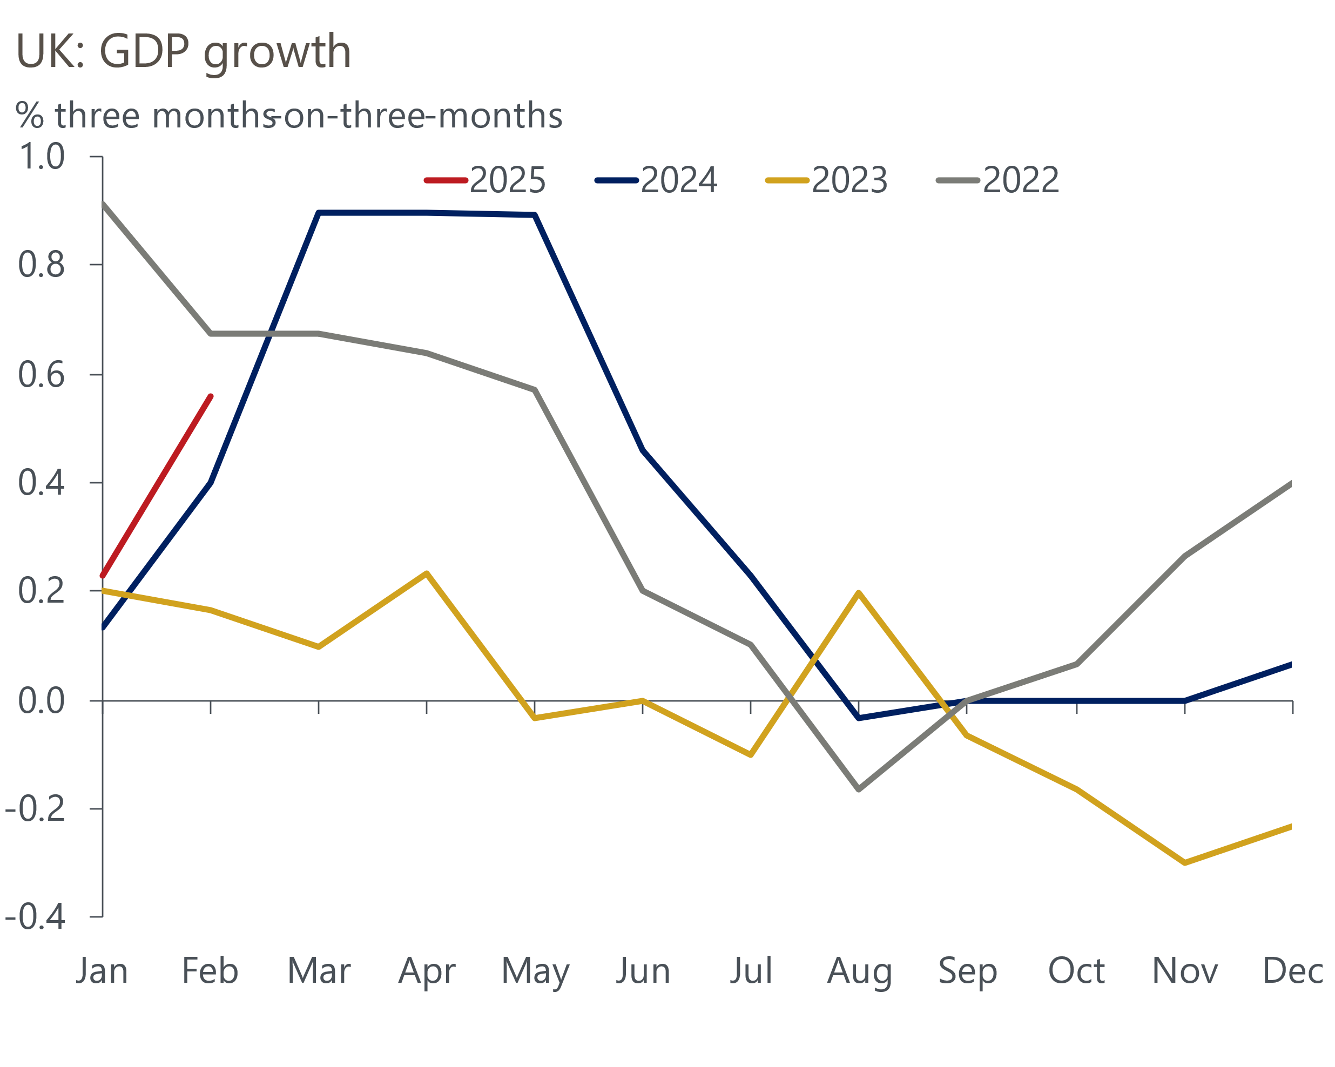
Source: Haver Analytics
This means quarterly growth is likely to be 0.5%-0.6% in Q1. And though we will cut our forecasts for the rest of the year, the Q1 strength will likely keep our forecast for UK GDP growth in 2025 at 1%. But our forecast for calendar year growth in 2026 is now likely to drop below 1%.
Driven by the sell-off of US assets this week, there has also been a dramatic repricing of UK government bonds. Upward pressure has been greatest at the longer end of the curve, where there is much less liquidity. At market close on Thursday, the 30-year gilt yield was 30bps higher than at the start of the week, leaving yields 17bps above the level seen prior to the US tariff announcement on April 2.
In light of the market volatility, the Bank of England took the decision to temporarily halt the sale of long-dated government bonds under its quantitative tightening program. The BoE will now sell £750mn of short-dated bonds on April 14, rather than auctioning the £600mn of long-maturity bonds it had originally planned. This looks like a sensible precautionary measure and shouldn't be seen as a signal about the future of QT or monetary policy more broadly.
Financial market pricing now implies 83bps of cuts to Bank Rate over the rest of this year. This is far more than the 56bps of cuts that had been priced in at the start of April.
Monetary Policy Committee members struck a relatively cautious tone when speaking this week. In a discussion hosted by the Resolution Foundation prior to the suspension of most reciprocal tariffs, Deputy Governor Clare Lombardelli said that "tariffs are likely to depress growth" but suggested that the impact on inflation was less clear. Meanwhile, during a panel event with market news provider MNI on Thursday, Deputy Governor Sarah Breeden remarked that policymakers "just have to be more careful than normal" after the recent shocks from the pandemic and the war in Ukraine.
Since it began its rate-cutting cycle last August, the MPC has loosened policy at alternate meetings. But Breedon's reference to previous supply shocks chimes with our view that worries over the weakness of supply mean that the bar to pausing the rate-cutting cycle has been lowered by the US tariff announcements.

The week ahead
The first of next week's two major economic releases is the labour market data for December-February. Most official measures of pay growth suggested the strong momentum of late-2024 had started to fade in the three months to January. We think this trend is likely to have continued in February's data, particularly given that strong base effects are increasingly coming into play and pay settlements will increasingly reflect the impact of April's increase in employers' national insurance contributions. Therefore, we forecast headline total pay growth of 5.7% and regular pay growth of 6% for the three months to February.
On the quantities side, recent single-month Labour Force Survey results for unemployment have remained relatively stable, so the three-month average has been stable at 4.4% in the past three releases. There's little to suggest that this is likely to have changed in the three months to February, so we expect the three-month average to hold firm at 4.4%.
We estimate that CPI inflation fell to 2.6% in March. February's unusually weak reading in the volatile clothing category is likely to unwind in March. But we think this upward pressure is likely to be more than offset by strong base effects pushing down services inflation. In addition, weekly data from the Department of Environment and Climate Change suggests petrol prices fell 1.6% between February and March, having risen by 2.8% over the same period in 2024. This means the fuel category should have exerted a larger drag on headline inflation in March.
Table 1: Week ahead calendar
Date | Events | Period | Measure | Unit | Previous | Forecast
Apr 15 | LFS unemployment | Dec-Feb | Rate | % | 4.4 | 4.4
Apr 15 | Average earnings (total pay) | Feb | 3m, y/y | % | 5.8 | 5.7
Apr 15 | Average earnings (regular pay) | Feb | 3m, y/y | % | 5.9 | 6.0
Apr 16 | CPI inflation | Mar | m/m | % | 0.4 | 0.3
Apr 16 | CPI inflation | Mar | y/y | % | 2.8 | 2.6
Apr 16 | RPI inflation | Mar | m/m | % | 0.6 | 0.5
Apr 16 | RPI inflation | Mar | y/y | % | 3.4 | 3.4
Apr 16 | Land Registry house prices | Feb | y/y | % | 4.9 | 5.2
Source: Oxford Economics

Key forecasts
Table 2: UK forecast overview
(Annual percentage changes unless specified)
 | 2022 | 2023 | 2024 | 2025 | 2026 | 2027
GDP | 4.8 | 0.4 | 0.9 | 1.0 | 1.5 | 1.7
Private consumption | 7.3 | 0.4 | 0.7 | 1.2 | 1.4 | 1.4
Fixed investment | 5.1 | 0.3 | 1.3 | 0.1 | 3.1 | 2.4
Government consumption | 0.6 | 1.0 | 2.0 | 2.4 | 1.6 | 1.6
Exports of goods and services | 12.6 | -3.2 | -2.2 | -1.6 | 0.9 | 1.3
Imports of goods and services | 13.0 | -4.5 | 1.6 | 0.0 | 1.5 | 1.2
Industrial Production | -6.4 | -0.9 | -1.7 | -0.8 | 0.8 | 1.0
Consumer prices | 9.1 | 7.3 | 2.5 | 3.2 | 2.6 | 2.2
Unemployment rate (%) | 3.8 | 4.1 | 4.3 | 4.5 | 4.5 | 4.3
Current a/c balance (% of GDP) | -2.2 | -2.2 | -2.8 | -2.9 | -2.9 | -2.7
Government balance (% of GDP) | 4.1 | 5.2 | 5.0 | 3.7 | 3.1 | 2.4
Central bank policy rate (%, EOP) | 3.50 | 5.25 | 4.75 | 3.75 | 3.00 | 2.50
10yr govt. bond yield (%, EOP) | 3.67 | 3.54 | 4.57 | 4.54 | 3.93 | 3.44
Exchange rate (US$ per £, EOP) | 1.20 | 1.27 | 1.25 | 1.25 | 1.25 | 1.26
Exchange rate (euro per £, EOP) | 1.13 | 1.15 | 1.21 | 1.21 | 1.21 | 1.21
Source: Oxford Economics
Table 3: Quarterly forecasts for the UK
 | 2024 |  |  |  | 2025
 | Q1 | Q2 | Q3 | Q4 | Q1 | Q2 | Q3 | Q4
GDP (% year) | 0.5 | 0.9 | 1.0 | 1.4 | 0.8 | 0.7 | 1.0 | 1.3
CPI inflation (% year) | 3.5 | 2.1 | 2.1 | 2.5 | 2.8 | 3.2 | 3.5 | 3.2
Bank Rate (%, EOP) | 5.25 | 5.25 | 5.00 | 4.75 | 4.50 | 4.25 | 4.00 | 3.75
10yr gilt yield (%, EOP) | 3.95 | 4.17 | 4.00 | 4.57 | 4.70 | 4.67 | 4.63 | 4.54
US$ per £ (EOP) | 1.26 | 1.26 | 1.34 | 1.25 | 1.28 | 1.25 | 1.25 | 1.25
Euro per £ (EOP) | 1.17 | 1.18 | 1.20 | 1.21 | 1.20 | 1.21 | 1.21 | 1.21
Source: Oxford Economics

Latest Country Economic Forecast:
March 18, 2025

Recent publications

Data Insights
February's sharp rise in GDP overstates underlying strength
Stronger services PMI likely still understates Q1 pick up in GDP
Manufacturing sector continues to face significant challenges
The gentle slowdown in mortgage activity continued in February
February's retail data consolidated January's rebound in sales

Research Briefings
Trump tariffs will cut UK growth as global demand weakens
Stopgap Spring Statement leaves problems unresolved
Will (mild) stagflation continue?
Why official data are less reliable and what this means
The MPC remains on autopilot

Contacts

Oxford Economics' UK team
- Andrew Goodwin - Chief UK Economist - agoodwin@oxfordeconomics.com
- Edward Allenby - UK Economist - eallenby@oxfordeconomics.com

